Executive Summary
This report comprises of the quick overview of the tableau visualisation and its outcomes based on the visualisations. The quick rundown is primary beer sales months are during summers i.e. July and August. The top vendors are Diego North America and Crown imports for retail and warehouse sales respectively. If we need to concentrate on releasing new flavour in Beer it needs to be done during those months.

Objectives
- Understand sales trends and identify peak sales platforms across vendors for drinks.
- Determine key products to target for boosting overall sales.
- Highlight regions and campaigns that are most effective for marketing specific drinks.
- Recommend optimal category and launch period for a new product.

Data source and methodology
- Sales Data: Kaggle, year 2020, Quarterly months
- Tools Used: ETL (Python), initial Analysis (Postgre SQL), Visualisation (Tableu)

Key Insights
- Maximum sales from the different sales categories is for Beer.
- Maximum sales observed is between July and August
- Top supplier among the provided data is DIAGEO NORTH AMERICA who has sold maximum quantity of Liquor and Beer together in retail sales.
- Top supplier among warehouses is CROWN IMPORTS who has sold maximum quantity of Beer.
- Overall top drink in retail sales is Liquor and along with it is Beer.

Sample Screenshots of the visualisations:
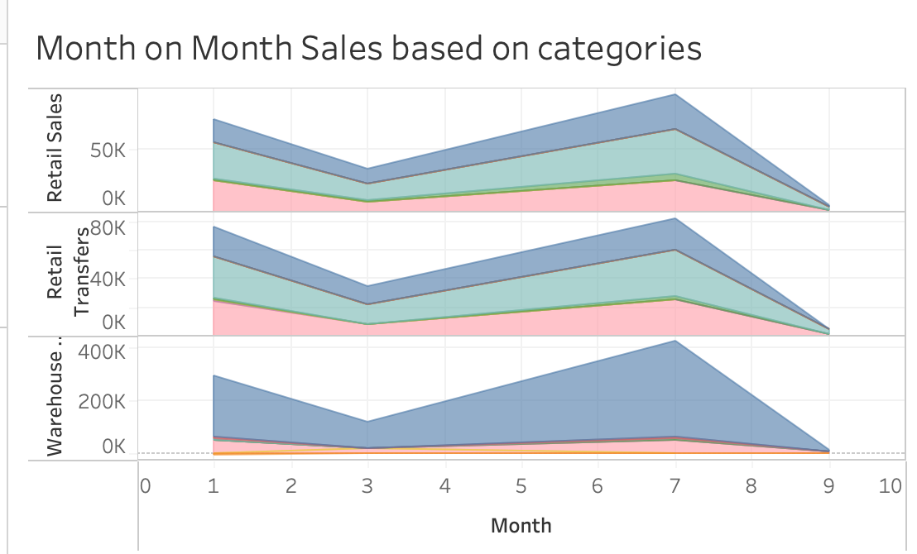

Recommendations:
- Very low sales are of non-alcoholic drinks and based on the current health and healthy trends in market, we can concentrate on running campaigns for non-alcoholic drinks which would boost the sales of that category.
- As the plan was to find any specific time of the year to launch new beer flavours, it would be during July and august and the maximum sales of beer occurs during those months. Assuming the data is considered only for northern hemisphere, those months are summer and that constitutes of more consumption of beer during those months.

